Linux, Apache, MySQL (MariaDB), PHP (LAMP) stack On CentOS 7

### Introduction

A "LAMP" stack is a group of open source software that is typically installed together to enable a server to host dynamic websites and web apps. This term is actually an acronym which represents the **L**inux operating system, with the **A**pache web server. The site data is stored in a **M**ySQL database (using MariaDB), and dynamic content is processed by **P**HP.

In this guide, we'll get a LAMP stack installed on an CentOS 7 VPS. CentOS will fulfill our first requirement: a Linux operating system.

## Step One — Install Apache

The Apache web server is currently the most popular web server in the world, which makes it a great default choice for hosting a website.

We can install Apache easily using CentOS's package manager, yum. A package manager allows us to install most software pain-free from a repository maintained by CentOS. You can learn more about [how to use yum](https://www.digitalocean.com/community/tutorials/how-to-set-up-and-use-yum-repositories-on-a-centos-6-vps) here.

For our purposes, we can get started by typing these commands:

sudo yum update -y

sudo yum install httpd

Since we are using a sudo command, these operations get executed with root privileges. It will ask you for your regular user's password to verify your intentions.

Afterwards, your web server is installed.

Once it installs, you can start Apache on your VPS:

sudo systemctl start httpd.service

You can do a spot check right away to verify that everything went as planned by visiting your server's public IP address in your web browser (see the note under the next heading to find out what your public IP address is if you do not have this information already):

http://your_server_IP_address/

You will see the default CentOS 7 Apache web page, which is there for informational and testing purposes. It should look something like this:

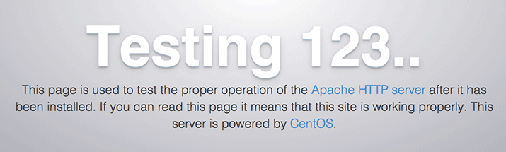

If you see this page, then your web server is now correctly installed.

## Step Two — Install MySQL (MariaDB)

Now that we have our web server up and running, it is time to install MariaDB, a MySQL drop-in replacement. MariaDB is a community-developed fork of the MySQL relational database management system. Basically, it will organize and provide access to databases where our site can store information.

Again, we can use yum to acquire and install our software. This time, we'll also install some other "helper" packages that will assist us in getting our components to communicate with each other:

sudo yum install mariadb-server mariadb

When the installation is complete, we need to start MariaDB with the following command:

sudo systemctl start mariadb

Now that our MySQL database is running, we want to run a simple security script that will remove some dangerous defaults and lock down access to our database system a little bit. Start the interactive script by running:

sudo mysql_secure_installation

The prompt will ask you for your current root password. Since you just installed MySQL, you most likely won’t have one, so leave it blank by pressing enter. Then the prompt will ask you if you want to set a root password. Go ahead and enter Y, and follow the instructions:

Enter current password for root (enter for none):

OK, successfully used password, moving on...

Setting the root password ensures that nobody can log into the MariaDB

root user without the proper authorization.

New password: password

Re-enter new password: password

Password updated successfully!

Reloading privilege tables..

... Success!

For the rest of the questions, you should simply hit the "ENTER" key through each prompt to accept the default values. This will remove some sample users and databases, disable remote root logins, and load these new rules so that MySQL immediately respects the changes we have made.

The last thing you will want to do is enable MariaDB to start on boot. Use the following command to do so:

sudo systemctl enable mariadb.service

At this point, your database system is now set up and we can move on.

## Step Three — Install PHP

PHP is the component of our setup that will process code to display dynamic content. It can run scripts, connect to our MySQL databases to get information, and hand the processed content over to our web server to display.

We can once again leverage the yum system to install our components. We're going to include the php-mysql package as well:

sudo yum install php php-mysql

This should install PHP without any problems. We need to restart the Apache web server in order for it to work with PHP. You can do this by typing this:

sudo systemctl restart httpd.service

## Step Four — Test PHP Processing on your Web Server

In order to test that our system is configured properly for PHP, we can create a very basic PHP script.

We will call this script info.php. In order for Apache to find the file and serve it correctly, it must be saved to a very specific directory, which is called the "web root".

In CentOS 7, this directory is located at /var/www/html/. We can create the file at that location by typing:

sudo vi /var/www/html/info.php

This will open a blank file. We want to put the following text, which is valid PHP code, inside the file:

<?php phpinfo(); ?>

When you are finished, save and close the file.

If you are running a firewall, run the following commands to allow HTTP and HTTPS traffic:

sudo firewall-cmd --permanent --zone=public --add-service=http

sudo firewall-cmd --permanent --zone=public --add-service=https

sudo firewall-cmd --reload

Now we can test whether our web server can correctly display content generated by a PHP script. To try this out, we just have to visit this page in our web browser. You'll need your server's public IP address again.

The address you want to visit will be:

http://your_server_IP_address/info.php

The page that you come to should look something like this:

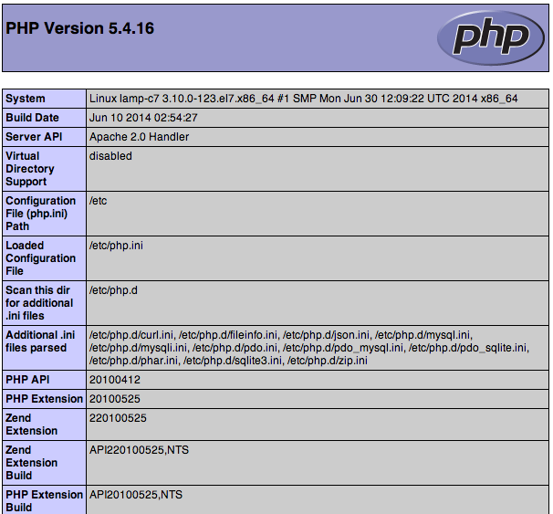

This page basically gives you information about your server from the perspective of PHP. It is useful for debugging and to ensure that your settings are being applied correctly.

If this was successful, then your PHP is working as expected.

You probably want to remove this file after this test because it could actually give information about your server to unauthorized users. To do this, you can type this:

sudo rm /var/www/html/info.php

You can always recreate this page if you need to access the information again later.